Daniel FX
DANIEL ANDECHE +254746673819
RISE AND FALL STRATEGY

RISE AND FALL STRATEGY
INDICATORS TO USE WHEN ANALYSING RISE AND FALL MARKET;
- MOVING AVERAGE
- MACD
- STOCASTIC RSI
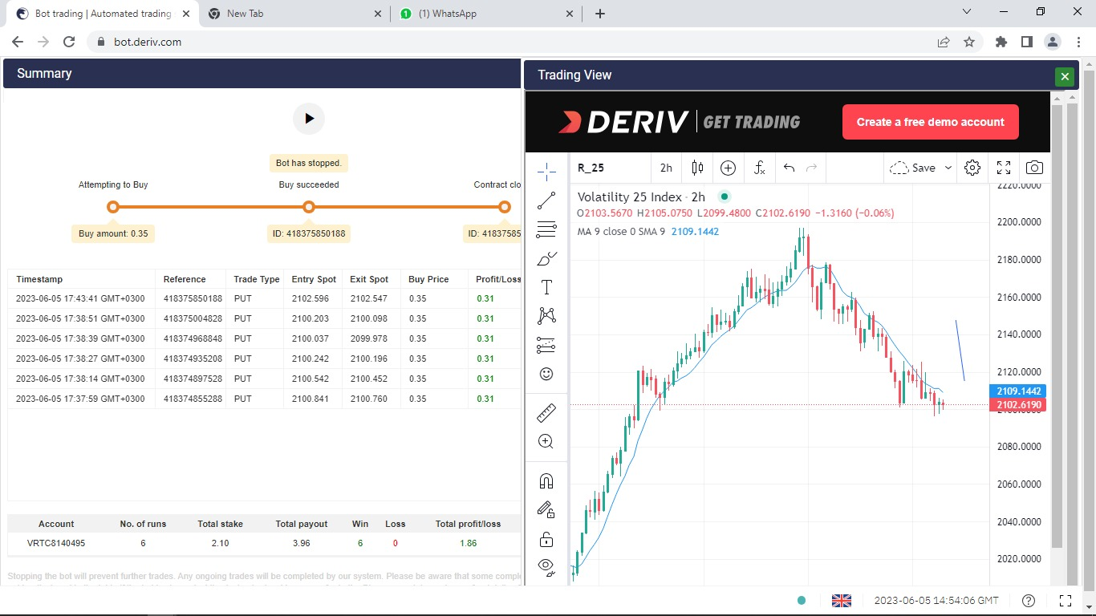

STEP 1. CHECK WHICH MARKET IS BEST FOR TRADING. (ALWAYS USE A HIGHER TIMEFRAME)

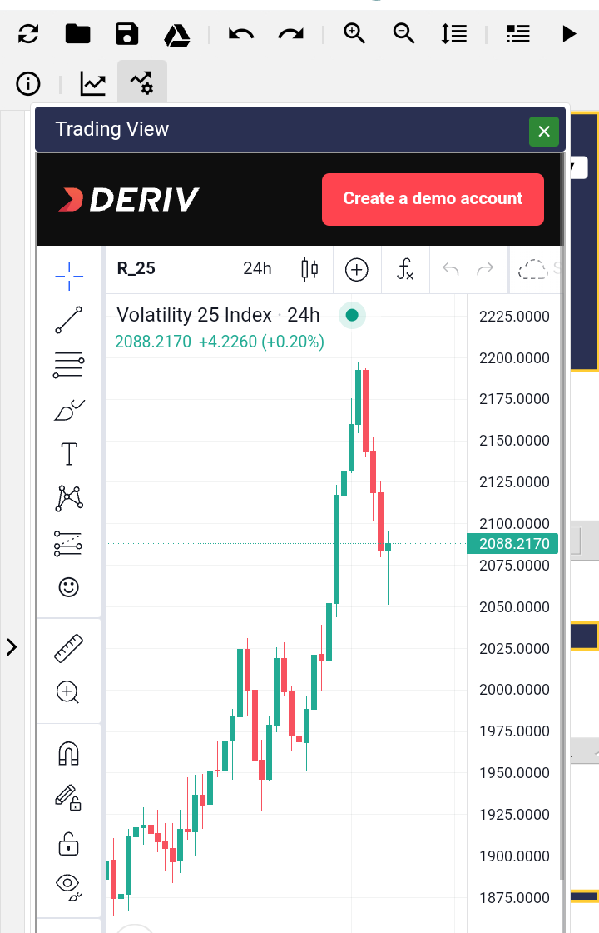
NOTE; Always make sure that all information on the chat to be same as in the bot.

STEP 2: CHANGE YOUR TIMEFRAME TO (4 HOURS) MOST RECOMMENDED.

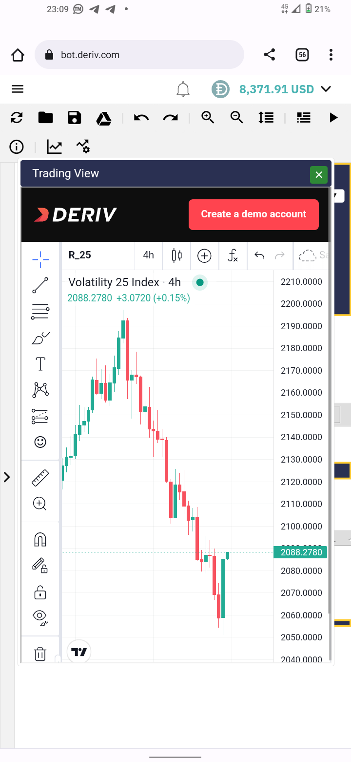

STEP 3: ADD INDICATORS
Click on the FX icon and add the following indicators
- MOVING AVERAGE
- MACD
- STOCHASTIC RSI

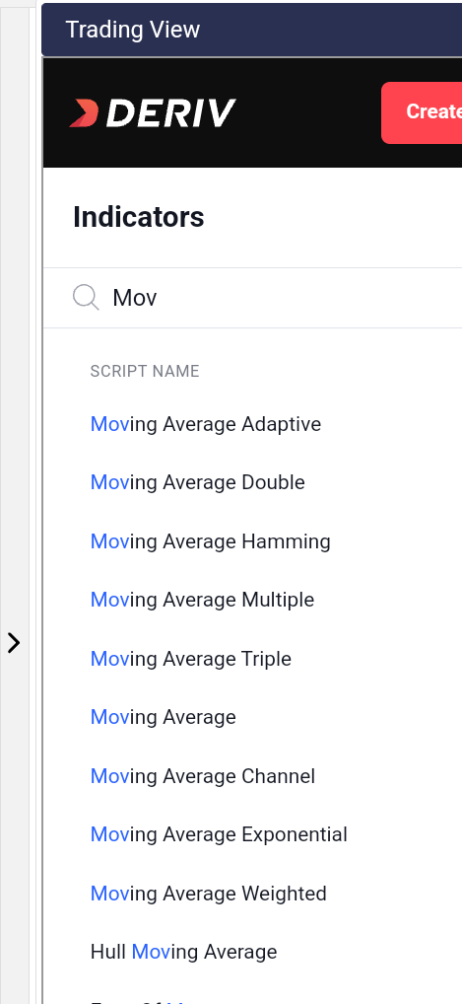

NOW LETS SEE THE IMPLICATION OF EACH INDICATOR AND HOW IT CAN HELP US KNOWING WHEN TO ENTER THE MARKET
- MOVING AVERAGE
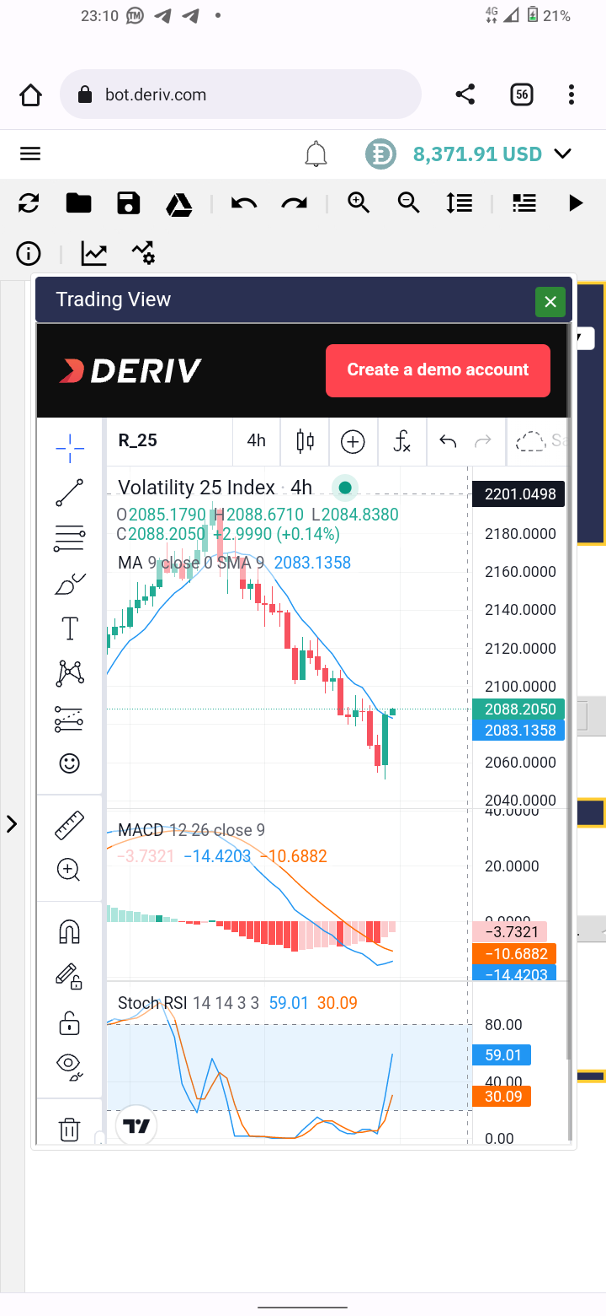

The blue line is what we call MOVING AVERAGE (MA). Its used to calculate the average of a markets movements over a longer time frane.
WHEN THE MOVING AVERAGE IS ABOVE THE CANDLESTICK, WE TRADE FALL, VICE VERSER RISE
On an uptrend, the MA is bellow the candlestick and on downtrend, the MA is above the candlestick.
SO WE CAN SAY,
- UPTREND, RISE
- DOWMTREND, FALL

- MACD

MACD has two lines BLUE and RED.
On an UPTREND, BLUE line is above the RED line
On a DOWNTREND, it’s the vice versa
When the two lines are about to meet that indicates market change.

STOCHASTIC RSI performs similar task as the MACD so will not talk about them.

ANOTHER INDICATOR OF A GOOD MARKET TO TRADE RISE AND FALL

WHEN ON AN UPTREND AND THE VALUE KEEP INCREASING, RUN THE BOT, VICE VERSA IS ALSO TRUE

LAST THING AND IS A COMMON ERROR PEOPLE COMMITE, BOT SETTINGS
BEFORE RUNNING BOT, MAKE SURE YOU;
- MARKET
- TRADE TYPE
- CONTRACT TYPE
- CANDLE INTERVAL
ARE IN LINE WITH YOUR ANALYSIS

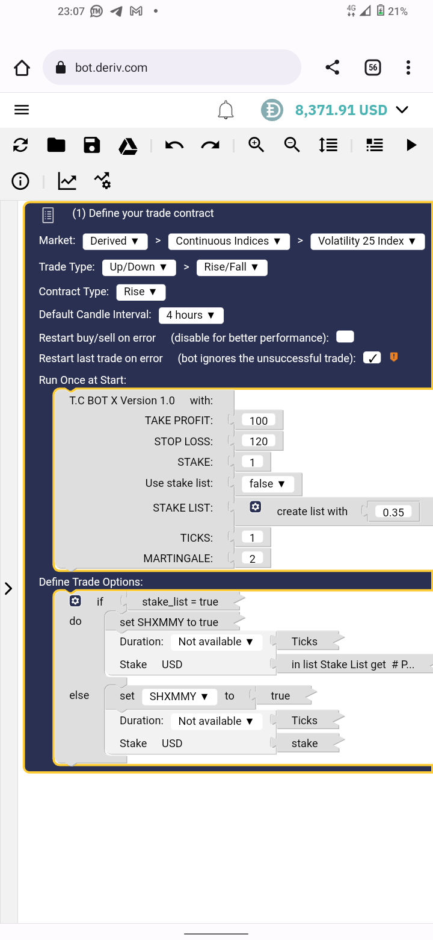
THIS DOCUMENT HAS BEEN PRODUCED BY:
DANIEL ANDECHE
+254746673819
IF YOU FIND IT USEFULL, SEND YOUR TOKEN OF APPRECIATION TO:
MPESA
0794674137
WHATSAPP ME IF YOU HAVE ANY QUERRY

